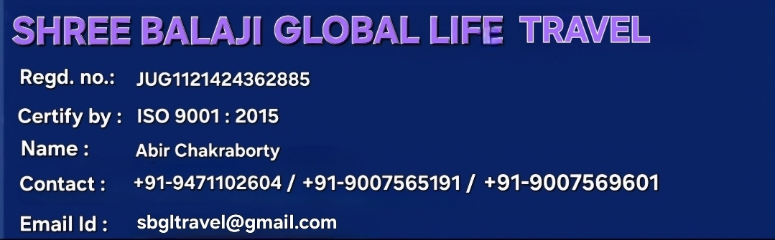



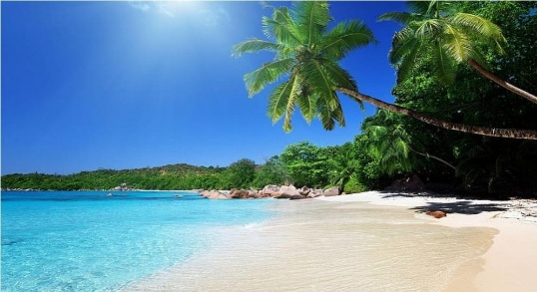
Bali Tour Packages
Tata to Tata (8 Days) Tour Plan
Day Wise Itinerary:

Stay
Kuta
Ubud

Destination Covered
- Tanjung Benoa
- Garuda Wisnu Kencana (GWK)
- Uluwatu Temple
- Kecak and Fire dance show
- Jimbaran Bay
- Taman Ayun Temple
- Bedugul (Bratan Lake)
- Jatiluwih Rice Terrace
- Tanah Lot Temple
- Celuk Village
- Tegenungan Waterfal
- Bali Aloha Ubud Swing
- Ubud Monkey Forest
- Gate of Heaven, Lempuyang Temple
- Tirta Gangga Water Palace
- Tukad Cepung Waterfall

(1st Day) Sightseeing
- Airport Pickup and Meetup
- Hotel Drop
- Lunch at Hotel
- Day Free to take Rest or visit nearby Market for Shopping
- Dinner at hotel

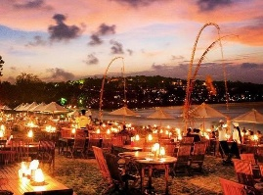
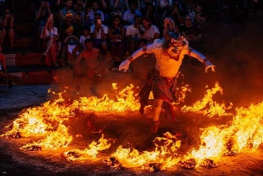
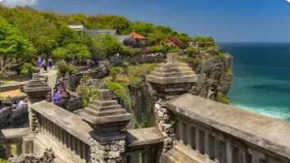
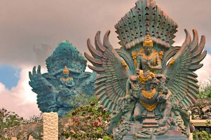
(2nd Day) Sightseeing

- After Breakfast Hotel Pickup
- First destination Tanjung Benoa
- Visit Garuda Wisnu Kencana (GWK), the tallest Landmark in Bali, 3rd in the world. The statue of Wisnu God ride the magical Garuda Bird.
- Having Lunch at Local Restaurant
- Next destination Uluwatu Temple, sacred temple of Bali Island.
- Visit Kecak and Fire dance show
- Last stop will continue by Sea food dinner at Jimbaran Bay Seafood. The café on white Sandy beach serving seafood with romantic evening.
- Hotel Drop then Rest

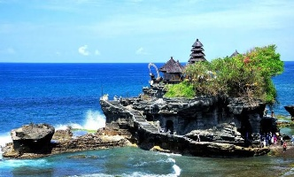
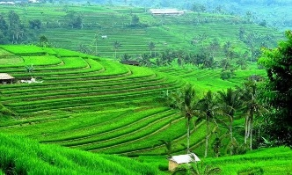

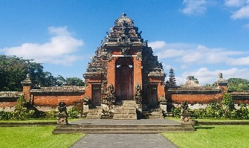
(3rd Day) Sightseeing

- Hotel Pick Up
- Breakfast at the Hotel
- First destination is Taman Ayun Temple, A Temple with beautiful garden and is generally Regarded as one of the most attractive temples of Bali.
- Stop at Bedugul (Bratan Lake) the temple well known with Ulundanu Temple Beautiful Floating temple in Bali.
- Continue to the biggest rice terrace in Bali “Jatiluwih Rice Terrace” and awarded as UNESCO HERITAGE SITE
- Having Lunch at Local Restaurant, overlooking rice paddies and later take a walk through The rice paddies
- Last destination is Tanah Lot Temple, beautiful temple built on a rocky in the sea. Looks Like floating on the sea.
- Dinner at Local Restaurant
- Hotel Drop then Rest

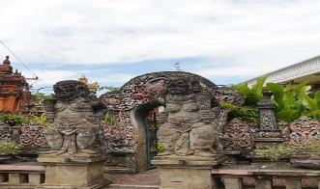
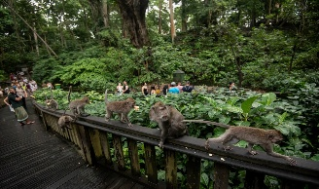

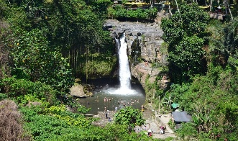
(4th Day) Sightseeing
- Hotel Pick Up
- Breakfast at the Hotel
- First destination is Celuk Village, famous for Gold and silver crafting
- Tegenungan Waterfal, hidden waterfall in Ubud with amazing beautiful view
- Bali Aloha Ubud Swing
- Having Lunch at local restaurant.
- Ubud Monkey Forest, the home of more than 600 long-tailed macaques.
- Dinner at Local Restaurant
- Hotel Drop then Rest

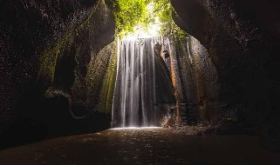
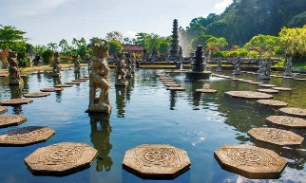
(5th Day) Sightseeing

- Hotel Pick Up
- Breakfast at the Hotel
- First stop to Gate of Heaven, Lempuyang Temple
- Tirta Gangga Water Palace, a royal palace in eastern Bali.
- Having Lunch at Local Restaurant
- Tukad Cepung Waterfall one of the most unique and photogenic waterfalls
- Dinner at Local Restaurant
- Hotel Drop then Rest.

(6th Day)
- Drop To Airport as Per Flight Schedule.

Package Included:
- Meals as per Itinerary (Breakfast, Lunch & Dinner)
- Visa Included
- Tata to Kolkata Airport (Up & Down)
- Comfortable Airconditioned vehicle
- Accommodation during stay in Bali
- English speaking Guide and Driver
- All entrance tickets in Bali
- 1x free banana boat ride
- 1x Kecak fire dance show
- Bali Aloha Swing voucher
- Mineral water during tour
- Parking tickets
- Return Airport Transfer
- Package cost *59,000* /Rs.

Package Excluded:
- Personal Expenses
- Flight Ticket
- TIPS
- Documentation video, photo, drone
- Water Activities
Cancellation Policy :
- Minimum Cancellation is Rs. 5,000/- per Head.
- 25% Between 30-20 Days Before Tour Departure
- 50% Between 20-10 Days Before Tour Departure
- 75% Between 10-05 Days Before Tour Departure
- 100% on the Same Day & No show.

